Specific Gravity (Rice) Test with 2,000 gram Vacuum Pyknometer
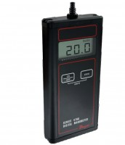 | Residual Pressure Manometer  Code: 45-9330  Attributes: Description = Residual Pressure Manometer  Standards: ASTM D2041, EHS 9300, AASHTO T209, AASHTO T283

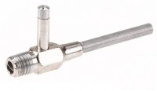 | Aspirator Type Filter Pump  Code: 45-9311  Attributes: Description = Aspirator Type Filter Pump  Standards:

 | Rice Test Vibrator 115vAC, 50/60 Hz  Code: 45-9315/02  Attributes: Description = Rice Test Vibrator 115 V AC 50/60 Hz, Dimensions, h x dia, ” = 19-1/2 x 12  Standards: ASTM D2041, AASHTO T209

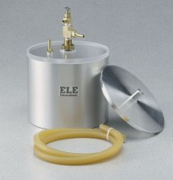 | Vacuum Pyknometer (2,000 gram)  Code: 45-9310  Attributes: Description = Vacuum Pyknometer (2,000 gram)  Standards: ASTM D2041, AASHTO T209, AASHTO T283

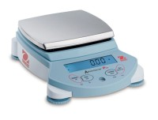 | High Capacity Electronic Balance  Code: 88-1094/02  Attributes: Description = High Capacity Electronic Balance  Standards:

Plastic Filtering Flask
Code: 88-6230
Attributes: Description = Plastic Filtering Flask
Standards:

Filtering Kit
Code: 45-9301
Attributes: Description = Filtering Kit
Standards:

