Mechanical Analysis Stirrer
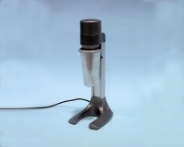 | High Speed Stirrer Complete with Paddle Cup & Baffle. 220-240V 50/60Hz 1Ph.  Code: 24-4125/01  Attributes: Description = High speed stirrer, Power Supply = 220 - 240 V AC, 50 - 60 Hz, 1 ph  Standards: BS 1377, ASTM D422, AASHTO T88

 | Mixing Paddle for 24-4125 Series High Speed Stirrer  Code: 24-4125/10  Attributes: Description = Mixing paddle (spare)  Standards: BS 1377, ASTM D422, AASHTO T88

Soil Dispersion Cup & Baffle.
Code: 24-4125/11
Attributes: Description = Dispersion cup and baffle (spare)
Standards: BS 1377, ASTM D422, AASHTO T88

Sodium Hexametaphosphate 500G.
Code: 24-4145
Attributes: Description = Sodium Hexametaphosphate, Weight, lbs = 1
Standards: ASTM D422, AASHTO T88, ASTM E100

