Sand Equivalent Shaker
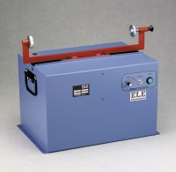 | Sand Equivalent Shaker  Code: 24-4949/02  Attributes: Timing Circuit = Built-in; 45 seconds, 10 minute and continuous run., Description = Sand Equivalent Shaker  Standards: ASTM D2419, AASHTO T176, CA 217, CA 229

 | Sand Equivalent Cylinder  Code: 24-4917/10  Attributes: Dimensions, diameter x length, ” = 1-1/4 x 17, Description = Sand Equivalent Cylinder  Standards: ASTM D2419, AASHTO T176

