Hubbard-Carmick Specific Gravity Bottles
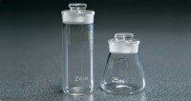 | Hubbard-Carmick Specific Gravity Bottle  Code: 46-2190  Attributes: Specific gravity bottle type = Hubbard-Carmick Specific Gravity Bottle, Capacity, ml = 25  Standards: ISO 3838, BS 4699, ASTM D70, AASHTO T228

Hubbard-Carmick Specific Gravity Bottle
Code: 46-2191
Attributes: Specific gravity bottle type = Hubbard-Carmick Specific Gravity Bottle, Capacity, ml = 24
Standards: ISO 3838, BS 4699, ASTM D70, AASHTO T228

