Champ II Series Bench Scales
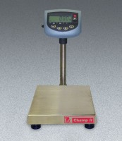 | Champ II Series Bench Scale - 60 lb / 30 kg Capacity  Code: 88-1302/02  Attributes: Rated Power = 100-240vAC 50/60 Hz internal universal power supply (included) or six “C” batteries (not included)., Description = Champ II Series Bench Scale - 60 lb / 30 kg Capacity  Standards:

