Los Angeles Abrasion Machine
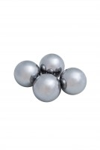 | Set of 12 Abrasive Charges EN)  Code: 42-5305/10  Attributes: Description = 12 EN Abrasive Charges  Standards: EN 1097-2, ASTM C131, ASTM C535

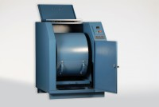 | Los Angeles Abrasion Machine with CE Safety Cabinet W/ Microswitches. 220-240V 50Hz 1Ph.  Code: 42-5310/01  Attributes: Description = Los Angeles Abrasion Machine with CE Safety Cabinet 220 - 240 V 50Hz, Power Supply = 220 - 240 V AC, 50 Hz, 1 ph  Standards: EN 1097-2, ASTM C131, ASTM C535, NF P18-573

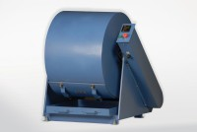 | Los Angeles Abrasion Machine Meets ASTM and European Standards. 220-240V 50Hz 1Ph.  Code: 42-5305/01  Attributes: Description = Los Angeles Abrasion Machine 220- 240 V AC 50Hz, Motor hp, amp = 1 HP  Standards: EN 1097-2, ASTM C131, ASTM C535, AASHTO T96, NF P18-573

Set of 12 Abrasive Charges (ASTM).
Code: 42-5300/10
Attributes: Description = 12 ASTM Abrasive Charges, Weight, lbs = 11.3
Standards: EN 1097-2, ASTM C131, ASTM C535, AASHTO T96

