Vacuum Pyknometer (6,000 Gram)
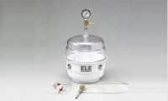 | Vacuum Pyknometer, 6000 g  Code: 45-9300  Attributes: Description = Vacuum Pyknometer (6,000 gram)  Standards: EN 12697-5, ASTM D2041, AASHTO T209, AASHTO T283

 | Filtering Kit  Code: 45-9301  Attributes: Description = Filtering Kit  Standards:

Drierite Desiccant
Code: 45-9315/14
Attributes: Description = Drierite Desiccant
Standards:

1/4" O.D Plastic Tubing
Code: 45-9301/14
Attributes: Description = 1/4″ O.D Plastic Tubing
Standards:

