Gas Jar Method
 | Gas Jar 75mm Dia X 300mm with Glass Cover and Rubber Bung.  Code: 24-2830  Attributes: Description = Gas jar, Capacity, litres = 1 litre  Standards: BS 1377, EN 1997-2

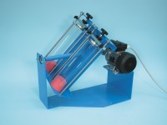 | Mechanical End-Over-End Shaker Ce with Friction Safety Device and Control Panel 220-240V 50Hz 1Ph.  Code: 24-2854/01  Attributes: Description = Mechanical end-over-end shaker, Power Supply = 220 - 240 V AC, 50 - 6- Hz, 1ph  Standards: BS 1377, EN 1997-2

