Cylinder Capping Set
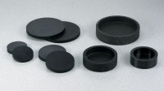 | Cylinder Capping Set  Code: 3000/01  Attributes: Description = Cylinder Capping Set 220 V AC 50/60 Hz, Rated Power = 220vAC, 50/60 Hz, 1ø. 1,250 Watts.  Standards: ASTM C31, ASTM C192, ASTM C617, AASHTO T231, ASTM T126

Cylinder Capping Set
Code: 3000/02
Attributes: Description = Cylinder Capping Set 110 V AC 50/60 Hz, Rated Power = 110vAC, 50/60 Hz, 1ø. 1,250 Watts.
Standards: ASTM C31, ASTM C192, ASTM C617, AASHTO T231, ASTM T126

