Aggregate Crushing Value (ACV) and Ten Percent Fines Value (TFV)
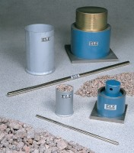 | 150mm Aggregate Crushing Value Apparatus. Supplied Complete with Metal Measure and Tamping Rod.  Code: 42-4300  Attributes: Description = 150 mm Aggregate Crushing Value Apparatus, Weight, kg = 16.6  Standards: BS 812-112

75mm Aggregate Crushing Value Apparatus. Supplied Complete with Metal Measure and Tamping Rod.
Code: 42-4500
Attributes: Description = 75 mm Aggregate Crushing Value Apparatus, Weight, kg = 3.5
Standards:

 | Tamping Rod 8mm Dia X 300mm.  Code: 42-4580  Attributes: Description = Tamping Rod, Main body length, arm, operating length mm = 8 x 300  Standards:

