General Cell Accessories
 | Piston Restraint Clamp for Ele Triaxial Cells  Code: 25-4200  Attributes: Description = Piston Restraint Clamp, Weight, lbs = 1.075  Standards: BS 1377, ASTM D2850, ASTM D4767, AASHTO T296, AASHTO T297

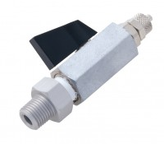 | Valve No Volume Change 1/4 Inch BSp Fitted with 6 mm Connector and Integral Sealing Ring.  Code: 25-4520  Attributes: Description = No volume change valve, Weight, lbs = 0.292  Standards: ASTM D2850, ASTM D4767, ASTM D7181, AASHTO T296, AASHTO T297

High Vacuum Grease
Code: 88-3115
Attributes: Dimensions w x d x h, ” = 190x50x40 mm, Description = High Vacuum Grease
Standards:

