Soil Moisture
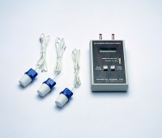 | Soil Moisture Meter.  Code: 514-126  Attributes: Description = Soil Moisture Meter  Standards:

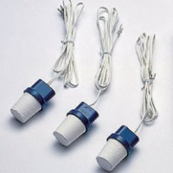 | Soil Moisture Block 0.9 m Lead  Code: 514-128  Attributes: Description = Soil Moisture Block, Lead Length = 0.9 m  Standards:

Soil Moisture Block 2.7 m Lead
Code: 514-130
Attributes: Description = Soil Moisture Block, Lead Length = 2.7 m
Standards:

Soil Moisture Block 4.5 m Lead
Code: 514-132
Attributes: Description = Soil Moisture Block, Lead Length = 4.5 m
Standards:

