Precision Sample Splitters
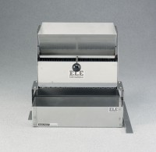 | Precision Sample Splitter - 14 chutes, 1/8” (3.18 mm) blade width  Code: 23-3360  Attributes: Hopper = 2-1/16 x 3-3/4” (52 x 95 mm)., Description = Precision Sample Splitter - 14 chutes, 1/8” (3.18 mm) blade width  Standards:

Precision Sample Splitter - 32 chutes, 1/4” (6 mm) blade width
Code: 23-3370
Attributes: Hopper = 6-5/8” x 8-15 /16” (168 x 22 7 mm)., Description = Precision Sample Splitter - 32 chutes, 1/4” (6 mm) blade width
Standards:

Precision Sample Splitter - 16 chutes, 1/2” (13 mm) blade width
Code: 23-3380
Attributes: Hopper = 6-7/8” x 7-15 /16” (175 x 202 mm)., Description = Precision Sample Splitter - 16 chutes, 1/2” (13 mm) blade width
Standards:

