Microcomputer pH Meter
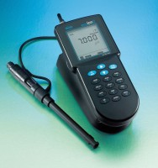 | Microcomputer pH Meter  Code: 88-2000  Attributes: Environment, °F = 32 ° F. to 122 ° F. (0°C to 50°C); 95% RH., Description = Microcomputer pH Meter  Standards:

 | Spare pH Electrode  Code: 88-2000/10  Attributes: Description = Spare pH Electrode  Standards:

