Particle Density: Pyknometer Methods
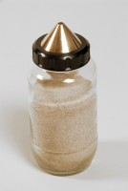 | Pyknometer Complete with Non-Corrodable Cone and Rubber Seal 1Kg Capacity  Code: 24-2885  Attributes: Description = Pyknometer, Gasket diameter, i.d; o.d ” = 2-1/4” (57.2 mm) i.d.; 2-7/8” (73 mm) o.d.  Standards: BS 1377, BS 812-2, EN 1097-7, EN 1997-2, ASTM D854, AASHTO T100, ASTM C128, AASHTO T84

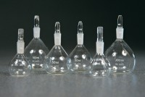 | Density Bottle 25Ml.  Code: 24-2890  Attributes: Description = Density bottle, Capacity, ml = 25  Standards: ASTM C128, AASHTO T84, BS 1377, BS 812-2

50Ml Density Bottle with Perforated Stopper.
Code: 24-2900
Attributes: Description = Density bottle, Capacity, ml = 50
Standards: ASTM C128, AASHTO T84

100Ml Density Bottle with Perforated Stopper.
Code: 24-2950
Attributes: Description = Density bottle, Capacity, ml = 100
Standards: ASTM C128, AASHTO T84

