Masonry Saw
 | Masonry Saw  Code: 82-8950/01  Attributes: Description = Masonry Saw, Power Supply = 220 - 240 V AC, 50 Hz, 1 ph  Standards:

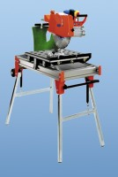 | Diamond Blade  Code: 82-8950/12  Attributes: Description = Diamond Blade, Nominal Diameter, mm = 350 mm  Standards:

