Marshall Stability Tester
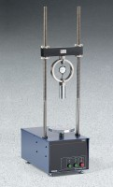 | Marshall Stability Tester  Code: 45-6832/02  Attributes: Rated Power = 110vAC, 60 Hz, 1ø., Description = Marshall Stability Tester  Standards: ASTM D6927, AASHTO T245

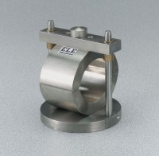 | 4" Marshall Breaking Head  Code: 45-6855  Attributes: Base diameter, ” = 6, Description = 4″ Marshall Breaking Head  Standards: ASTM D6927, AASHTO T245

 | 4" Lottman Breaking Head  Code: 45-6860  Attributes: Strips = 3" l. x 1/2" w. x 3/4" h. (76.2 x 12.7 x 19 mm) with 2" (50.8 mm) radius on contact end., Description = 4″ Lottman Breaking Head  Standards: ASTM D6931, AASHTO T283

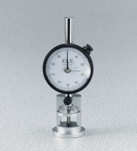 | Asphalt Flow Indicator with Brake - English  Code: 45-6892  Attributes: Weight, oz. = 12, Description = Asphalt Flow Indicator with Brake - English  Standards: ASTM D6927, AASHTO T245

Asphalt Flow Indicator with Brake - Metric
Code: 45-6894
Attributes: Weight, oz. = 12, Description = Asphalt Flow Indicator with Brake - Metric
Standards: ASTM D6927, AASHTO T245

Proving Ring 10,000 lbf Capacity
Code: PR-100
Attributes: Description = Proving Ring 10,000 lbf Capacity
Standards:

