Multi-Purpose Field Scales
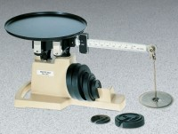 | Multi-Purpose Field Scale - 36 lb Capacity  Code: 88-1600  Attributes: Description = Multi-Purpose Field Scale - 36 lb Capacity  Standards:

Multi-Purpose Field Scale - 16 kg Capacity
Code: 88-1610
Attributes: Poise = Sliding, Description = Multi-Purpose Field Scale - 16 kg Capacity
Standards:

