Crack Detection
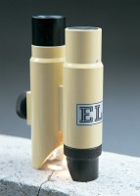 | Crack Detection Microscope Magnification X 40 Measuring Range of 4mm In 0.02mm Divisions  Code: 35-2505  Attributes: Description = Crack Detection Microscope, Divisions = 0.02  Standards:

