Tri-Flex 2 Master Control Panel
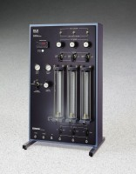 | Tri-Flex 2 Master Control Panel, English 220vAC  Code: 25-0696/01  Attributes: Utilities Required = Water, vacuum, air pressure, drain and AC power supply., Description = Tri-Flex 2 Master Control Panel, English 220vAC  Standards: ASTM D2850, ASTM D4767, ASTM D7181, ASTM D5084, AASHTO T296, AASHTO T297

Tri-Flex 2 Master Control Panel, English 110vAC
Code: 25-0696/02
Attributes: Utilities Required = Water, vacuum, air pressure, drain and AC power supply., Description = Tri-Flex 2 Master Control Panel, English 110vAC
Standards: ASTM D2850, ASTM D4767, ASTM D7181, ASTM D5084, AASHTO T296, AASHTO T297

Tri-Flex 2 Master Control Panel, Metric 220vAC
Code: 25-0697/01
Attributes: Utilities Required = Water, vacuum, air pressure, drain and AC power supply., Description = Tri-Flex 2 Master Control Panel, Metric 220vAC
Standards: ASTM D2850, ASTM D4767, ASTM D7181, ASTM D5084, AASHTO T296, AASHTO T297

Tri-Flex 2 Master Control Panel, Metric 110vAC
Code: 25-0697/02
Attributes: Utilities Required = Water, vacuum, air pressure, drain and AC power supply., Description = Tri-Flex 2 Master Control Panel, Metric 110vAC
Standards: ASTM D2850, ASTM D4767, ASTM D7181, ASTM D5084, AASHTO T296, AASHTO T297

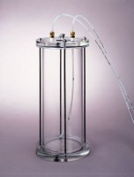 | Tri-Flex 2 Water De-airing Tank System  Code: 25-0698  Attributes: Capacity, gals = 1.4, Description = Tri-Flex 2 Water De-airing Tank System  Standards: ASTM D2850, ASTM D4767, ASTM D7181, ASTM D5084, AASHTO T296, AASHTO T297

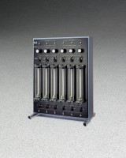 | Auxiliary Control Panel  Code: 25-0699  Attributes: Utilities Required = Water, vacuum, air pressure and drain<br>through connection to the Master<br>Control Panel., Description = Auxiliary Control Panel  Standards: ASTM D2850, ASTM D4767, ASTM D7181, ASTM D5084, AASHTO T296, AASHTO T297

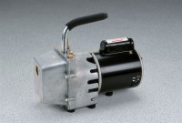 | High Vacuum Pump  Code: 88-3110/02  Attributes: Rated Power = 110vAC, 50/60 Hz, 1ø., Description = High Vacuum Pump  Standards:

