Volume Change Measurement
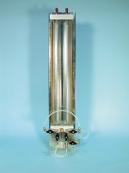 | Twin Burette Volume Change Unit.  Code: 26-1892  Attributes: Description = Twin burette volume change unit, Weight, kg = 8.3  Standards:

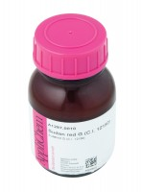 | Red Dye Kerosene Soluble 10G Phial for Colouring Kerosene.  Code: 26-1900  Attributes: Description = Red dye  Standards:

 | 6mm Connector 1/4BSp.  Code: 26-1922  Attributes: Description = 6mm Connector  Standards:

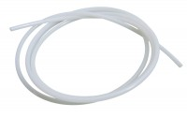 | Nylon Tubing 6mm Od 3500Kpa.  Code: 26-1926  Attributes: Description = Nylon tubing  Standards:

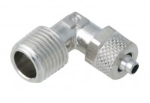 | 6mm Elbow Connector.  Code: 26-1928  Attributes: Description = Elbow connector  Standards:

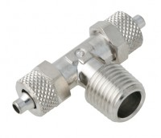 | 6mm T Connector.  Code: 26-1930  Attributes: Description = T connector  Standards:

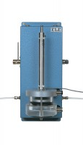 | Volume Change Transducer Assembly 80Cm3 Capacity Maximum Working Pressure 1700Kpa  Code: 27-1641  Attributes: Description = Volume change transducer assembly, Maximum Pressure, psi = 250  Standards:

