Setting Time by Penetration Resistance
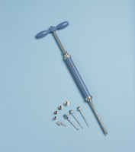 | Proctor Penetrometer Spring Type with Adaptor Stem.Supplied Complete with Set of Needle Points  Code: 29-3925  Attributes: Description = Proctor Penetrometer - complete with set of needle points, Weight, kg = 2  Standards: ASTM D1558

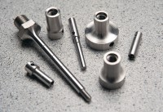 | Set of Needle Points 1 1/2 1/4 1/10 1/20 1/40 Inch Sq.  Code: 34-0810  Attributes: Description = Set of needle points  Standards:

 | Syringe with Rubber Bulb.  Code: 82-2820  Attributes: Description = Syringe with rubber bulb, Weight, kg = 0.5  Standards:

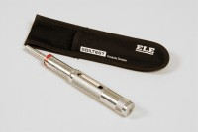 | Pocket Concrete Penetrometer  Code: 38-2695  Attributes: Description = Pocket Concrete Penetrometer, Dimensions, diam. X length, ” = 3/4” (19 mm) diam. x 7” (178 mm) long.  Standards: ASTM C187, ASTM C191, ASTM C780

