ELE Rotasift Laboratory Sifters
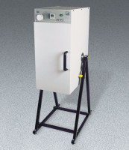 | ELE Rotasift Laboratory Sifter - 220V  Code: 80-0417/01  Attributes: Description = ELE Rotasift Laboratory Sifter - 220V  Standards:

ELE Rotasift Laboratory Sifter 110V
Code: 80-0417/02
Attributes: Description = ELE Rotasift Laboratory Sifter - 110V, Timer = Built-in
Standards:

