Sand Density Cone, 12"
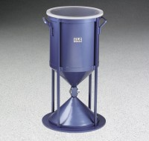 | Sand Density Cone 12"  Code: 29-4350  Attributes: Finish = Painted, Description = Sand Density Cone 12″  Standards: ASTM D4914

 | Density Sand  Code: 29-4355  Attributes: Particle Size = 2, Description = Density Sand  Standards: ASTM D1556, AASHTO T191

