Sieve Lids and Receivers ISO and BS
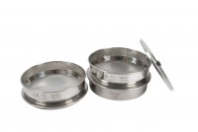 | 200 mm Diameter Lid  Code: 79-0010  Attributes: Sieve Type = Lid  Standards: BS 410, ISO 3310

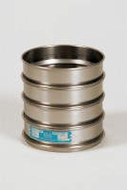 | 300mm Dia Lid.  Code: 79-2010  Attributes: Sieve Type = Lid  Standards: BS 410, ISO 3310

300mm Dia Receiver.
Code: 79-2020
Attributes: Sieve Type = Receiver
Standards: BS 410, ISO 3310

 | 200 mm Diameter Receiver  Code: 79-0020  Attributes: Sieve Type = Receiver  Standards: BS 410, ISO 3310

