Hoek Cells
 | Spare Jacket Nx Size.  Code: 70-1712  Attributes: Description = Hoek Cell Jacket  Standards:

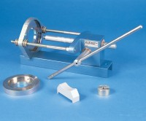 | Specimen Extruder Bench Mounting Frame for Extruding Specimens From Hoek Cells  Code: 70-2725  Attributes: Description = Specimen Extruder for Hoek Cells, Weight, kg = 11 kg  Standards:

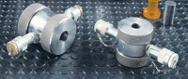 | Ele-Hoek Cell Nx 54.74mm Diameter.  Code: 70-1710  Attributes: Description = Hoek Cell 54.74mm Dia, Weight, kg = 14.5 kg  Standards:

