Rapid-Change Flexure Attachments
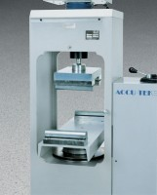 | Flexural Attachment  Code: 37-5526  Attributes: Description = Flexural Attachment - 79kg, Upper Head = Uses toe hitch design to mount to upper crosshead.  Standards: ASTM C78, ASTM C293, AASHTO T97

 | Flexural Attachment  Code: 37-5524  Attributes: Description = Flexural Attachment - 95 kg, Upper Head = Uses toe hitch design to mount to upper crosshead.  Standards: ASTM C78, ASTM C293, AASHTO T97

