De-Aired Water
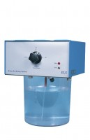 | De-Aired Water Apparatus 15 Litre Capacity  Code: 25-1833/01  Attributes: Self-Contained = Yes, Capacity, litres = 15 L  Standards:

