Mechanical Analysis Stirrer
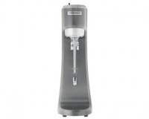 | Mechanical Analysis Stirrer 220-240vAC  Code: 24-4132/01  Attributes: Description = Mechanical Analysis Stirrer 220-240vAC  Standards: ASTM D422, AASHTO T88

Mechanical Analysis Stirrer 120vAC
Code: 24-4132/02
Attributes: Dispersion Cup = 5 stationary baffles, permanently mounted; rounded bottom., Description = Mechanical Analysis Stirrer 120vAC
Standards: ASTM D422, AASHTO T88

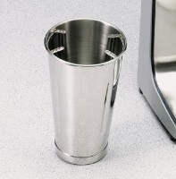 | Soil Dispersion Cup  Code: 24-4132/10  Attributes: Dispersion Cup = 4 stationary baffles, permanently mounted; rounded bottom., Description = Soil Dispersion Cup  Standards: ASTM D422, AASHTO T88

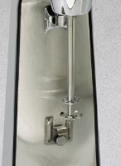 | Mixing Paddle  Code: 24-4132/11  Attributes: Weight, lbs = 0.02, Description = Mixing Paddle  Standards: ASTM D422, AASHTO T88

