Tensiometers
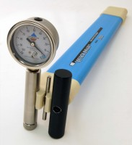 | Quickdraw soil moisture probe 305 mm  Code: 514-010  Attributes: Description = Soil moisture probe, Tensiometer Type = Quickdraw, Length, mm = 305 mm, Weight, kg = 1  Standards:

Quickdraw soil moisture probe 460 mm
Code: 514-012
Attributes: Description = Soil moisture probe, Tensiometer Type = Quickdraw, Length, mm = 460 mm, Weight, kg = 1
Standards:

 | Replacement Dial Gauge.  Code: 514-010/12  Attributes: Description = Dial Gauge  Standards:

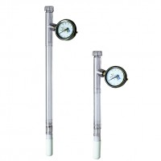 | Dial-Type Gauge Tensiometer 300 mm  Code: 514-020  Attributes: Description = Gauge Tensiometer, Tensiometer Type = Dial-Type, Length, mm = 300 mm  Standards:

Dial-Type Gauge Tensiometer 600 mm
Code: 514-022
Attributes: Description = Gauge Tensiometer, Tensiometer Type = Dial-Type, Length, mm = 600 mm
Standards:

Dial-Type Gauge Tensiometer 900 mm
Code: 514-024
Attributes: Description = Gauge Tensiometer, Tensiometer Type = Dial-Type, Length, mm = 900 mm
Standards:

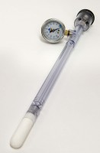 | JET Fill Tensiometer 150 mm  Code: 514-035  Attributes: Description = Tensiometer, Tensiometer Type = Jet Fill, Length, mm = 150 mm  Standards:

JET Fill Tensiometer 300 mm
Code: 514-036
Attributes: Description = Tensiometer, Tensiometer Type = Jet Fill, Length, mm = 300 mm
Standards:

Jet Fill Tensiometer 460 mm
Code: 514-037
Attributes: Description = Tensiometer, Tensiometer Type = Jet Fill, Length, mm = 460 mm
Standards:

Jet Fill Tensiometer 600 mm
Code: 514-038
Attributes: Description = Tensiometer, Tensiometer Type = Jet Fill, Length, mm = 600 mm
Standards:

Jet Fill Tensiometer 900 mm
Code: 514-040
Attributes: Description = Tensiometer, Tensiometer Type = Jet Fill, Length, mm = 900 mm
Standards:

Jet Fill Tensiometer 1220 mm
Code: 514-041
Attributes: Description = Tensiometer, Tensiometer Type = Jet Fill, Length, mm = 1220 mm
Standards:

Insertion Tool
Code: 514-030
Attributes: Description = Insertion Tool
Standards:

Service Kit
Code: 514-034
Attributes: Description = Service Kit
Standards:

Tensiometer Extension Tube
Code: 514-042
Attributes: Description = Tensiometer Extension Tube, Length, mm = 1524 mm
Standards:

