Digital Stopwatch
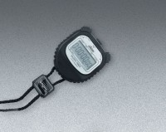 | Digital Stopwatch  Code: 88-4340  Attributes: Description = Digital Stopwatch  Standards:

