Sand Density Cones
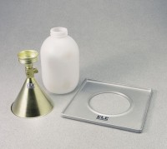 | 4" Sand Density Cone  Code: 29-4292  Attributes: Sand Jug = Plastic; 1 gal. (4,000 cu. cm) capacity., Description = 4″ Sand Density Cone  Standards: ASTM D1556, AASHTO T191

6" Sand Density Cone
Code: 29-4302
Attributes: Description = 6″ Sand Density Cone
Standards: ASTM D1556, AASHTO T191

Plastic Sand Jug
Code: 29-4292/10
Attributes: Description = Plastic Sand Jug
Standards: ASTM D1556, AASHTO T191

