Windsor HP Probe System
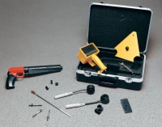 | Windsor HP Probe System  Code: 35-1450  Attributes: System Components = Drive unit, electronic measuring device, templates, measuring caps, gauge plates and carrying case., Description = Windsor HP Probe System  Standards: ASTM C803

 | Silver Probe Kit  Code: 35-1452  Attributes: Weight, lbs = 0.206, Description = Silver Probe Kit  Standards: ASTM C803

Gold Probe Kit
Code: 35-1454
Attributes: Weight, lbs = 0.216, Description = Gold Probe Kit
Standards: ASTM C803

