Bitumen Penetration Test
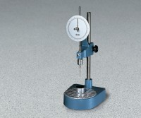 | Standard Penetrometer  Code: 46-5290  Attributes: Description = Standard Penetrometer  Standards: BS 2000-49, EN 1426, EN 13179-2, IP 49, ASTM D5, AASHTO T49

 | ASTM (Non-Certified) Penetration Needle  Code: 46-5290/10  Attributes: Description = ASTM (Non-Certified) Penetration Needle  Standards:

Transfer Dish
Code: 46-5800
Attributes: Description = Transfer Dish
Standards: BS 2000-49, EN 1426, EN 13179-2, ASTM D5, AASHTO T49, IP 49

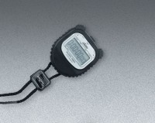 | Digital Stopwatch  Code: 88-4340  Attributes: Description = Digital Stopwatch  Standards:

Tin Sample Box, 3 oz
Code: 88-7022A
Attributes: Description = Tin Sample Box - 3 oz. Capacity
Standards:

Tin Sample Box, 6 oz
Code: 88-7026
Attributes: Description = Tin Sample Box - 6 oz. Capacity
Standards:

