Rubber Tubing
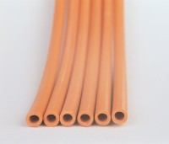 | Rubber Tubing  Code: 81-0375  Attributes: Description = Rubber Tubing  Standards:

