2" Cube Test System
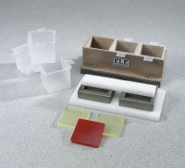 | 2" Cube Test System  Code: 39-0414  Attributes: Compression Pads = Polyurethane; 1/4” (6.3 mm) thick., Description = 2″ Cube Test System  Standards:

 | Plastic Disposable Liners  Code: 39-0414/10  Attributes: Description = Plastic Disposable Liners  Standards:

Compression Pads
Code: 39-0414/12
Attributes: Description = Compression Pads
Standards:

