Displacement Measurement
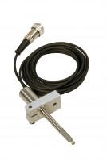 | Vertical Displacement Transducer Assembly 15mm Travel with 5 Pin Din Plug Bracket for Shear Box  Code: 27-1689  Attributes: Description = Vertical displacement transducer assembly 15 mm travel, Mounting Bracket = Included as standard.  Standards:

Horizontal Displacement Transducer Assembly 15mm Travel 5 Pin Din Plug Mounting Pillar
Code: 27-1697
Attributes: Description = Horizontal displacement transducer assembly 15 mm travel, Mounting Bracket = Included as standard.
Standards:

