Accessories for Concrete Moulds
 | Compacting Bar 25mm Sq X 380mm  Code: 34-2910  Attributes: Description = Compacting bar  Standards:

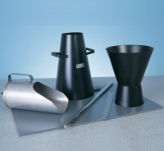 | Tamping Rod 16mm Dia X 600mm Long Hemispherical At Both Ends.  Code: 34-0130  Attributes: Description = Tamping Rod, Weight, kg = 0.95 kg  Standards:

Wire Brush
Code: 81-0705
Attributes: Description = Wire Brush, Weight, kg = 0.3
Standards:

Mould Oil (25 Litre Drum)
Code: 82-7341
Attributes: Description = Mould Oil, Capacity, litres = 25 litre
Standards:

