Motorized Liquid Limit Device
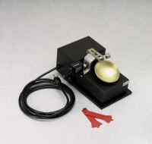 | Motorized Liquid Limit Device  Code: 24-0441/02  Attributes: Rated Power = 110vAC, 60 Hz, 1ø., Description = Motorized Liquid Limit Device  Standards: ASTM D4318, AASHTO T89

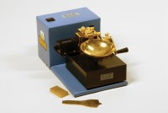 | Casagrande Grooving Tool Aashto  Code: 24-0461  Attributes: Description = Grooving tool, AASHTO Standard = Yes, Gauge height, cm = 1  Standards: ASTM D4318, AASHTO T89

 | ASTM Slider and Pin Cup Holder Assembly  Code: 24-0435/12  Attributes: Dimensions w x d x h, ” = 84x40x10 mm, Description = ASTM Slider and Pin Cup Holder Assembly  Standards: ASTM D4318, AASHTO T89

ASTM Plastic Grooving Tools
Code: 24-0451
Attributes: Gauge height, cm = 1, Description = ASTM Plastic Grooving Tools
Standards: ASTM D4318

Brass Cup
Code: 24-0435/10
Attributes: Dimensions w x d x h, ” = 88x88x2 mm, Description = Brass Cup
Standards: ASTM D4318, AASHTO T89

