Air Compressors
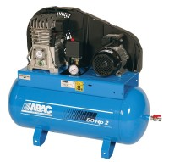 | Air Compressor  Code: 83-1735/01  Attributes: Description = Air Compressor Unit, Working Pressure, kPa = 1,000  Standards:

Air Compressor
Code: 83-1730/01
Attributes: Working Pressure, kPa = 700, Description = Air Compressor Unit
Standards:

