Ro-Tap Sieve Shakers
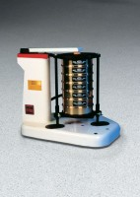 | Ro-Tap Sieve Shaker for 8" Diameter Sieves - 110V 60 Hz  Code: 80-0420/02  Attributes: Support Plate = Adjustable, Description = Ro-Tap Sieve Shaker for 8″ Diameter Sieves - 110V 60 Hz  Standards:

Ro-Tap Sieve Shaker for 8" Diameter Sieves - 220V 50 Hz
Code: 80-0420/01
Attributes: Support Plate = Adjustable, Description = Ro-Tap Sieve Shaker for 8″ Diameter Sieves - 220V 50 Hz
Standards:

Ro-Tap Sieve Shaker for 8" Diameter Sieves - 230V 60 Hz
Code: 80-0420/06
Attributes: Description = Ro-Tap Sieve Shaker for 8″ Diameter Sieves - 230V 60 Hz
Standards:

