Filter Papers (Box of 100)
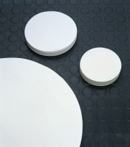 | Filter Paper - Fast  Code: 82-7861  Attributes: Description = Filter Paper - Fast, Diameter, mm = 55 x 400  Standards:

Filter Paper - Medium
Code: 82-7901
Attributes: Description = Filter Paper - Medium, Diameter, mm = 74 x 150
Standards:

Filter Paper - Slow
Code: 82-7931
Attributes: Description = Filter Paper - Slow, Diameter, mm = 95 x 110
Standards:

