Permeability of Concrete
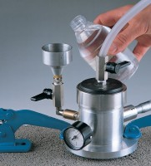 | Gwt Permeability Kit 0-6 Bar Range Supplied In A Carrying Case.  Code: 35-4043  Attributes: Description = Gwt Permeability Kit, Weight, kg = 3  Standards:

