Digital Thermometers
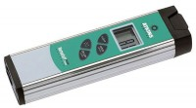 | Digital Thermometer  Code: 88-4420  Attributes: Resolution µs = 0.1° or 1° (selectable), Description = Digital Thermometer  Standards:

 | Heavy-Duty Needle Probe  Code: 88-4420/12  Attributes: Temperature Range, °F = -40 to 500, Description = Heavy-Duty Needle Probe  Standards:

Surface Temperature Probe
Code: 88-4420/14
Attributes: Temperature Range, °F = -40 to 1200, Description = Surface Temperature Probe
Standards:

