Soil Lathes
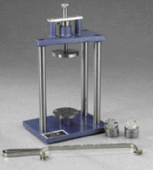 | 1.4" and 2.8" Hand Specimen Trimmer  Code: 23-5802  Attributes: Description = Hand Specimen Trimmer, 1.4" (35 mm) = Yes, 2.8" (70 mm) = Yes  Standards:

 | Trimming Knife  Code: 81-0710  Attributes: Description = Trimming Knife  Standards:

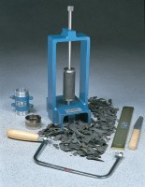 | Hand Operated Soil Lathe for 38mm Dia Specimens Up to 100mm Long.  Code: 23-5800  Attributes: Description = Hand Operated Soil Lathe, 38 mm Sample = Yes, Maximum specimen length = 100 mm, Specimen Diameter mm = 38 mm  Standards: BS 1377-1

