Circulating Water Bath
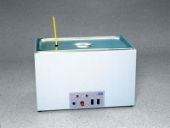 | Circulating Water Bath  Code: 45-6471/02  Attributes: Temperature Range °C = Ambient to 150°F, Description = Circulating Water Bath  Standards: ASTM D6927, AASHTO T245

