Versa-Loader
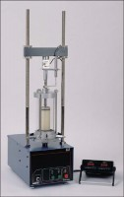 | Versa-Loader  Code: 25-3525/02  Attributes: Maximum Load, tsf = 10,000, Description = Versa-Loader  Standards: ASTM D1883, ASTM D2850, AASHTO T193, AASHTO T296, AASHTO T208

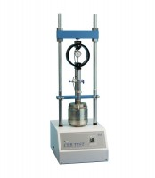 | CBR Test Accessory Set English  Code: 24-9175  Attributes: Dial Indicator = 1.0" Range, Description = CBR Test Accessory Set English  Standards: ASTM D1883, AASHTO T193

CBR Test Accessory Set Metric
Code: 24-9177
Attributes: Dial Indicator = 25 mm Range, Description = CBR Test Accessory Set Metric
Standards: ASTM D1883, AASHTO T193

 | CBR Test Accessory Set For Use with GDU  Code: 24-9185  Attributes: Capacity, lbs = 10,000, Description = CBR Test Accessory Set For Use with GDU  Standards: ASTM D1883, AASHTO T193

CBR Test Digital Readout (English)
Code: 27-1124/02
Attributes: Calibration, °F = english, Description = CBR Test Digital Readout (English)
Standards: ASTM D1883, AASHTO T193

CBR Test Digital Readout (Metric)
Code: 27-1125/02
Attributes: Calibration, °F = metric, Description = CBR Test Digital Readout (Metric)
Standards: ASTM D1883, AASHTO T193

CBR Data Logging Test
Code: 27-1126/02
Attributes: Calibration, °F = english, metric, Description = CBR Data Logging Test
Standards: ASTM D1883, AASHTO T193

