Heavy Duty Beam Forms
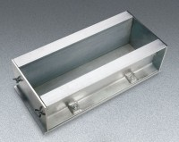 | Heavy-Duty Beam Forms  Code: 34-5055  Attributes: Description = Heavy-Duty Beam Form - 6 x 6 x 21"  Standards: ASTM C31, ASTM C78, ASTM C192, AASHTO T23, AASHTO T97, ASTM T126

Heavy-Duty Beam Forms
Code: 34-5057
Attributes: Description = Heavy-Duty Beam Form - 6 x 6 x 24"
Standards: ASTM C31, ASTM C78, ASTM C192, AASHTO T23, AASHTO T97, ASTM T126

