Chloride Field Test System
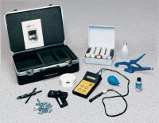 | Chloride Field Test System  Code: 35-2167  Attributes: Electrode = Chloride combination type with externally mounted<br>temperature sensor, cable and connectors., Description = Chloride Field Test System  Standards:

