Asphalt Sample Ejector
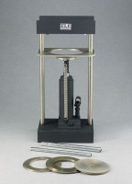 | Asphalt Sample Ejector  Code: 45-6480  Attributes: Construction = All metal; plated extrusion plates and piston discs; painted finish on housing and pump., Description = Asphalt Sample Ejector  Standards: ASTM D6926, AASHTO T245

